Exercise 1

Write a Program to enter three integers and output the smallest integer using IF.

**SOURCECODE:**

#include <iostream>

using namespace std;

//create a function to Print the Smallest Number:

int smallest(int a,int b, int c)

{

//Use if else condition to return the smallest one:

if(a<b && a<c)

{

return a;

}

else if(b<a && b<c)

{

return b;

}

else if(c<a && c<b)

{

return c;

}

}

int main()

{

//Declaring variables:

int a,b,c;

//Taking Input from user:

cout <<"Enter any three Integers"<<endl;

cin>>a>>b>>c;

cout<<"\nThe Smallest Number is: ";

cout<<smallest(a,b,c)<<endl<<"\n";

system("pause");

return 0;

}

**SCREENSHOT:**

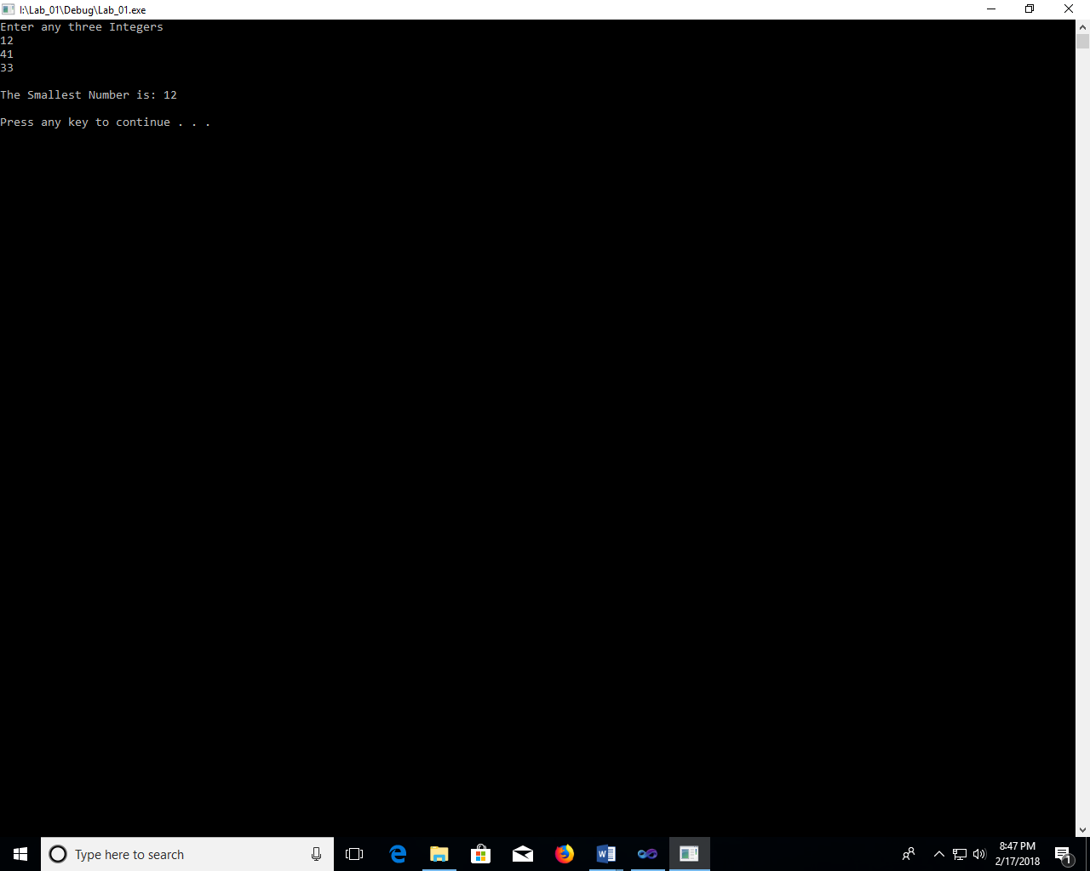

Exercise 2

Write a Program to enter 10 integers in a single-dimension array and then print out the array in ascending order.

**SOURCECODE:**

#include <iostream>

using namespace std;

//create a function to print an array in ascending order:

void Array_Sort(int arr[])

{

int temp;

//Use nested for loop to set an array in ascending order:

for(int i=0;i<10;i++)

{

for(int j=i+1;j<10;j++)

{

//if array element 1 is greater than array element 2 than swap these numbers

if(arr[i]>arr[j])

{

temp=arr[i];

arr[i]=arr[j];

arr[j]=temp;

}

}

}

//Print the sorted array:

cout<<"\nSorted Array in Ascending Order:\n";

for(int i=0;i<10;i++)

{

cout << arr[i];

cout<<endl;

}

}

int main()

{

int arr[10];

//take input of array from user:

for(int i=0;i<10;i++)

{

cout<<"Enter Element "<<i+1<<": ";

cin >> arr[i];

}

//Call Array_Sort function which prints sorted array:

Array_Sort(arr);

cout<<"\n";

system("pause");

return 0;

}

**SCREENSHOT:**

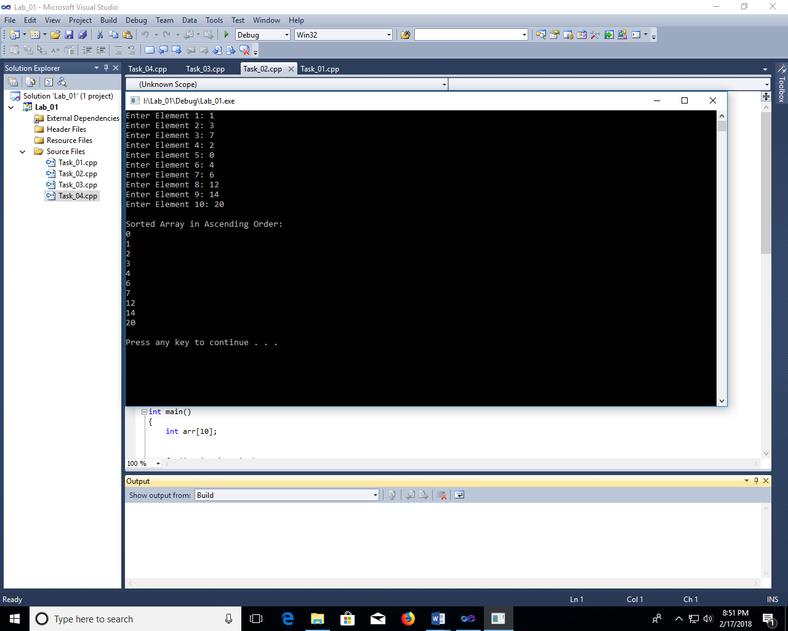

Exercise 3

Write a program to create structure named student. Take information of student from user as input (StdID, StdName, StdAge etc.) Display the output.

**SOURCECODE:**

#include <iostream>

using namespace std;

//create a structure of Student to which have student info :

struct student

{

int age,stdID;

char name[30];

};

int main() {

// create an object of student :

student std;

//take input of student id,name & age using structure:

cout << "Enter Student Full name : ";

cin.get(std.name, 30);

cout << "Enter Student ID : ";

cin >> std.stdID;

cout << "Enter Student age : ";

cin >> std.age;

//Print student Information :

cout << "\nFull Information of Student: " << endl;

cout << "\nID: " << std.stdID << endl;

cout << "Name: " << std.name << endl;

cout <<"Age: " << std.age << "\n\n";

system("pause");

return 0;

}

**SCREENSHOT:**

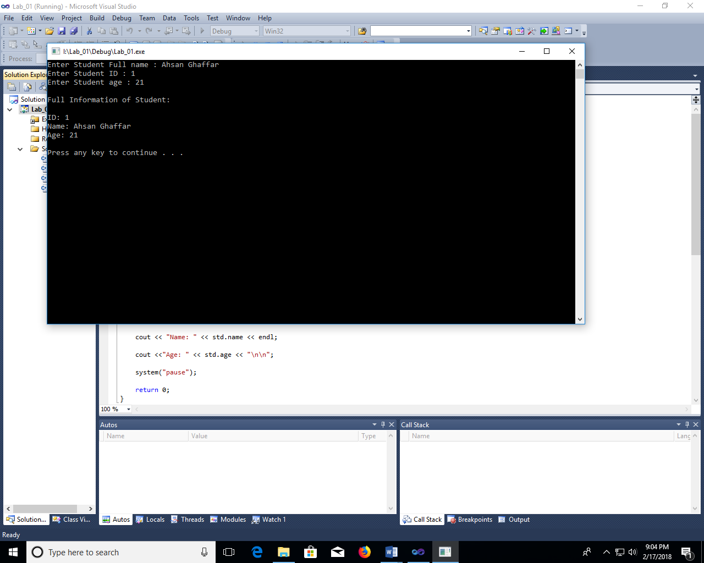

Exercise 4

Perform above task using pointers to structure

**SOURCECODE:**

#include <iostream>

using namespace std;

//create a structure of Student to which have student info :

struct student

{

int age,stdID;

char name[30];

};

int main() {

// create an object of student :

student *ptr,std;

//saves the object of student in ptr:

ptr = &std;

cout << "Enter Student Full name : ";

cin.get((*ptr).name, 30);

cout << "Enter Student ID : ";

cin >> (*ptr).stdID;

cout << "Enter Student age : ";

cin >> (*ptr).age;

cout << "\nFull Information of Student: " << endl;

cout << "\nID: " << (*ptr).stdID << endl;

cout << "Name: " << (*ptr).name << endl;

cout <<"Age: " << (*ptr).age << "\n\n";

system("pause");

return 0;

}

**SCREENSHOT:**

